NOTICE ABOUT EX SECCATOI TABACCO

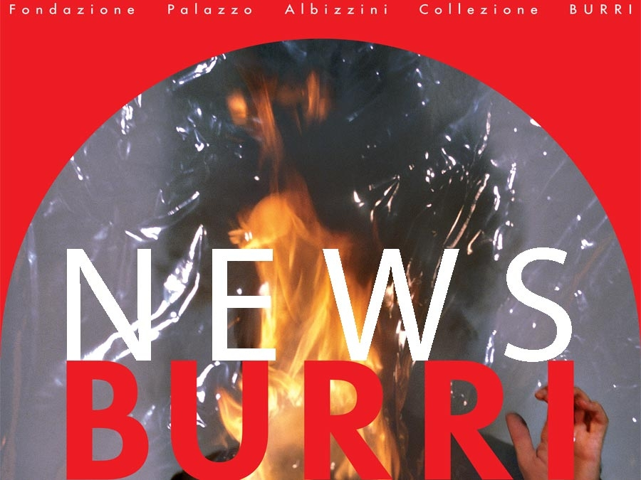
From January 7th to June, 2020 the major Cycles section at Ex Seccatoi Tabacco venue will be closed for renovation work. During this period - with a reduced ticket - visitors will be able to access to the following exhibition areas.
- Permanent Collection Graphic Work (196 works - from 1957 to 1994)
- The Multimedia Documents Section - BURRIDOCUMENTA: three areas that cover Alberto Burri’s life in full (Projection Areas - Interactive Area and two Cinema Rooms)

